**Name: Bhavesh Ashok Anandpara**

**Roll no.: 510**

**PRN: 2046491245010**

**MOOC Course Name: Oracle SQL**

**Duration: 3.5 hrs.**

**Provider: Great Learning**

**Course Coverage:**

The online course on **Oracle SQL** in depth is structured in such a way that it will cover all the basics of DATABASE and SQL. At the start of the course theory is covered so that we will have a good foundation of Database and later practical SQL queries are taught e.g., how to create a table how to write nested queries(sub-queries), functions, joins, relational model, etc.

All the core topics of SQL such as functions, clauses, and joins are taught, including miscellaneous and small topics around Oracle DBMS, which are used to write a query and find the resultant data for a problem in a database.

**Learnings:**

This 3.5 Hours of self-paced course introduced the issues/ problems associated with data, or databases; what are the security challenges, space, human and cost issues. How to set up the environment in your system for SQL? What is the relational model (projection, select, union, intersection, joins, etc.) covered. In SQL after getting hands-on commands on joins we learned different SQL commands of DDL, DML, DCL, TCL, then we learned what are the different data types, column aliases, keywords such as distinct, drop, delete, etc.

After learning keywords, we have been introduced to the relational operators. Then we move towards functions, where we come to learn there are two types of functions, single row and multiple row functions. We practiced a few SQL queries on functions and moved towards clauses, how to order by clause, group by clause by practicing on different queries.

**Screenshots:**

1. **Login Page.**

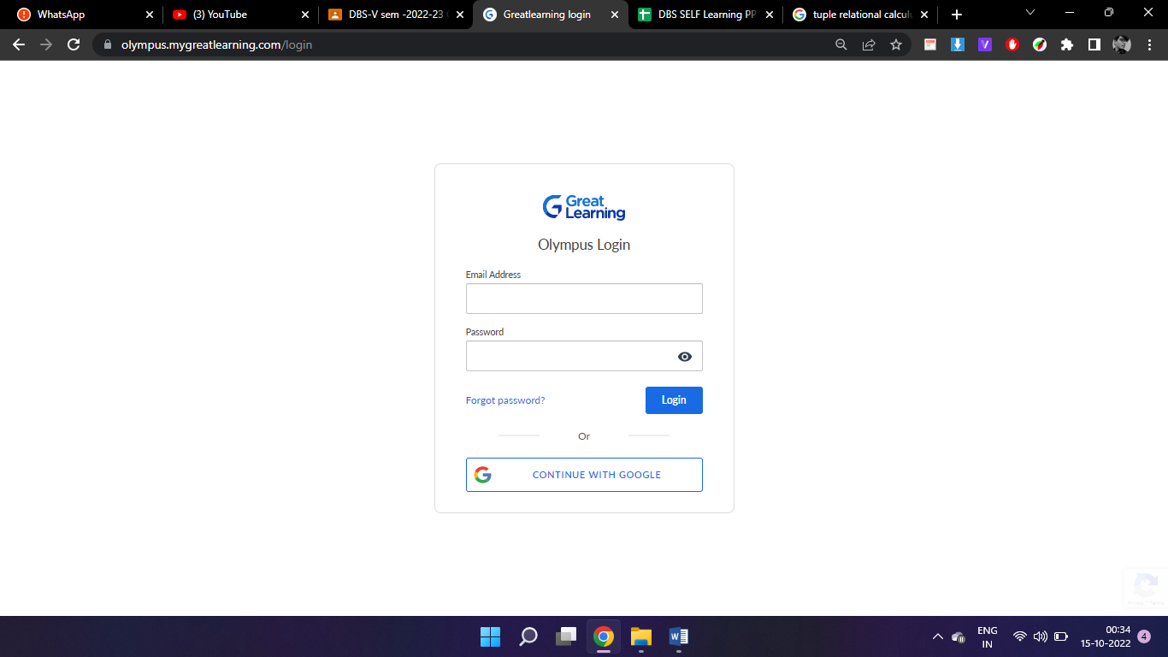

**2. Course Home page:**

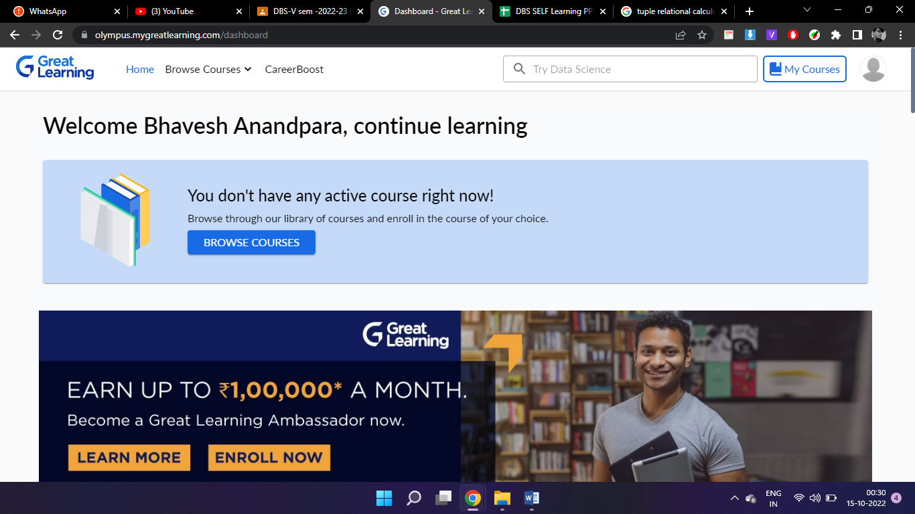

**3. Course Index Content Page:**

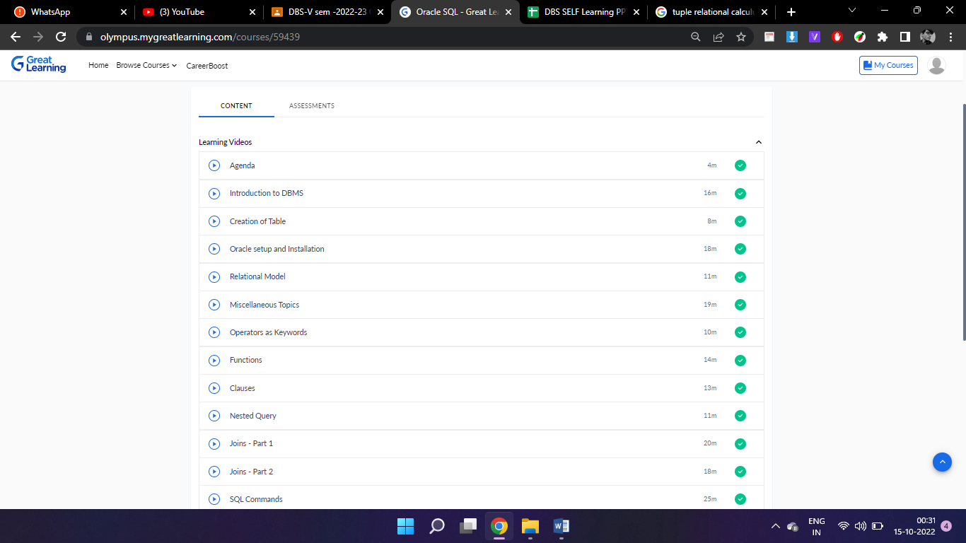

**4. Course Content page:**

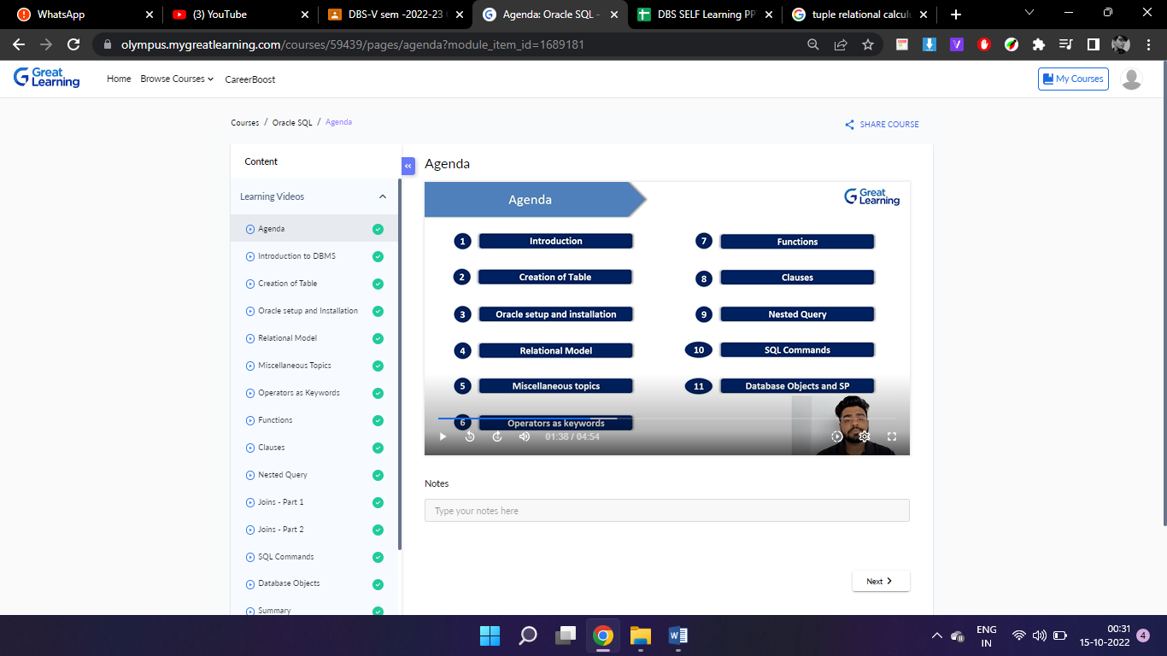

**5. Quiz Attempted:**

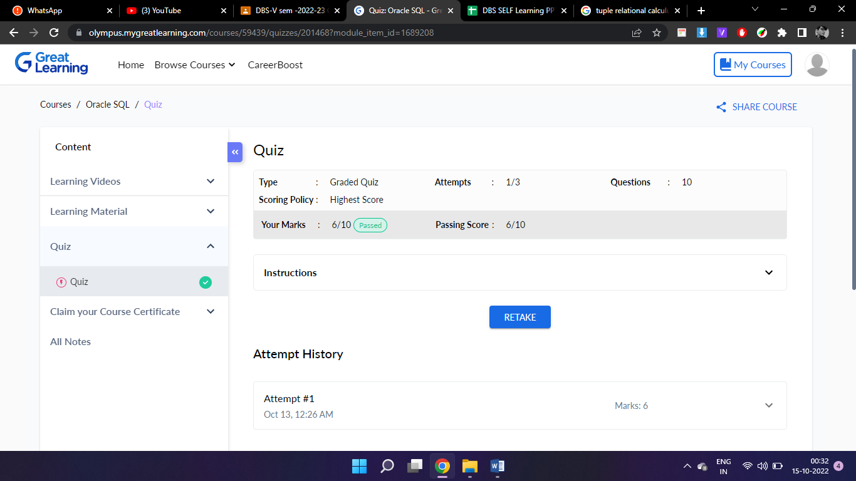

**6. Learner Record:**

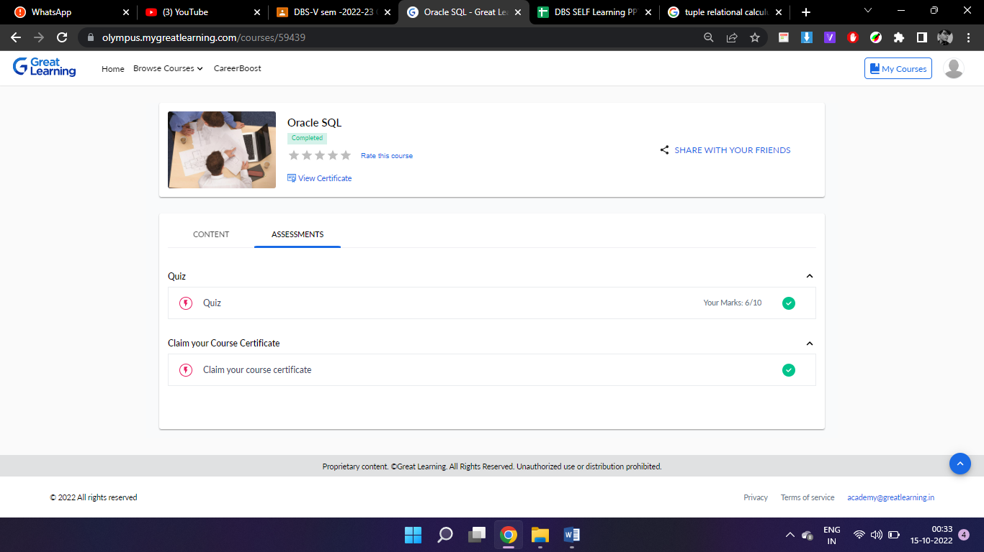

**7. Course Completion Details:**

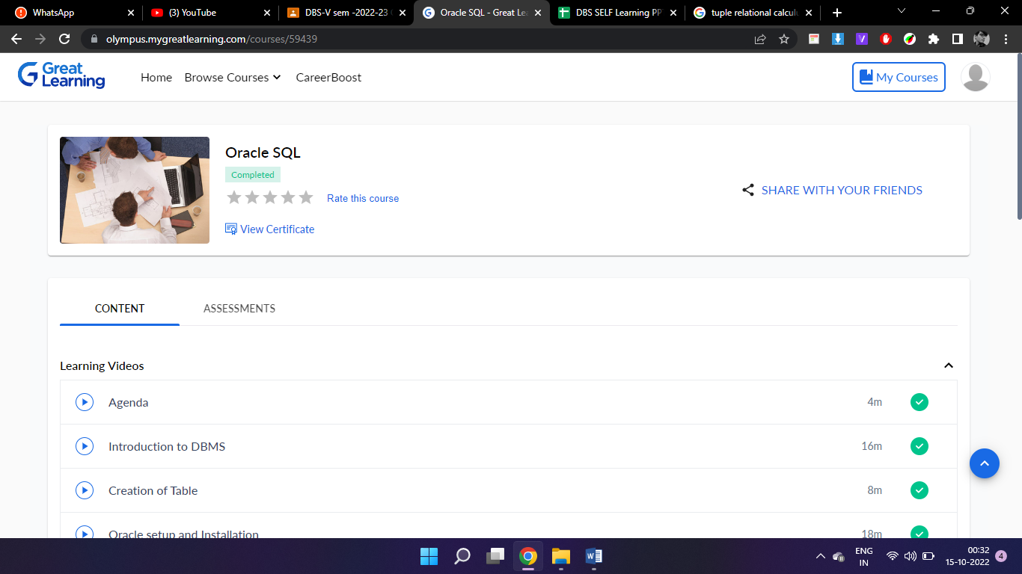

**8. Certificate**

